DIGITAL DESIGN CS223-3

PROJECT FINAL REPORT
Mert Alp TAYTAK 21602061
18.12.2017

- BLOCK DIAGRAM FROM PROGRESS REPORT:

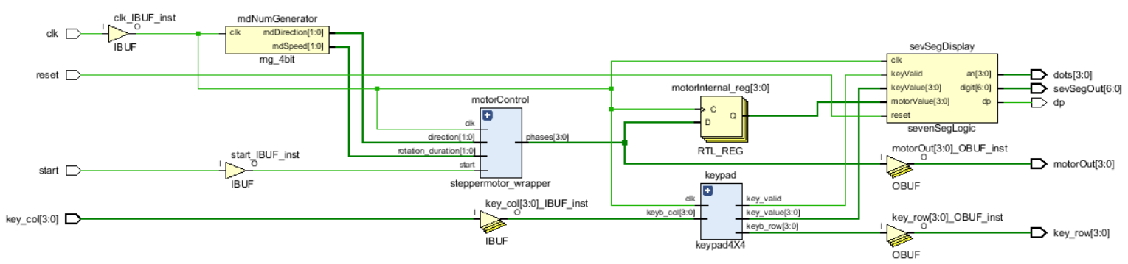
Larger picture can be found in Appendix A

- BLOCK DIAGRAM FROM FINISHED PROJECT:

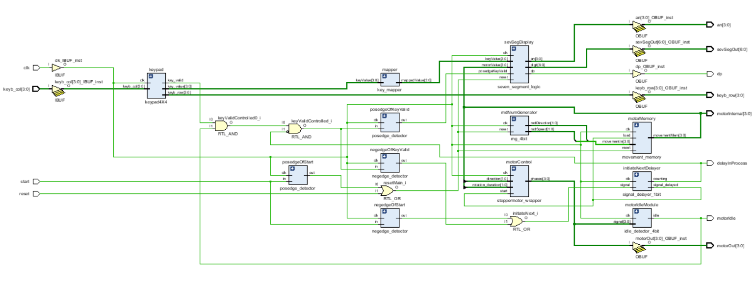
Larger picture can be found in Appendix B

- DIFFERENCES:
The main difference comes from addition of extra modules to implement new features. These features include denying input while motor motion is in progress and adding a delay between key press and motor motion to make checking score and keeping track of motor movement easier. Also, input start is taken from a button and it resets the game when the button is first pressed, then, motor movement is initiated upon button release. Most of the extra modules are edge detectors needed to implement these features.
Detailed explanation of finished implementation and modules is later in the report.

- MODULES, IMPLEMENTATION and USES:

a) game:
Top module that contains all the other modules. Organizes module connections and main input/output with internal wires and some combinational logic.

Implementation:
Modules given as part of the assignment and modules created for the project are connected according to the needed logic.
This logic simplified is:
- If start input is given, reset the game at rising edge and initiate a turn at falling edge.
- If reset input is given, reset the game.
- If any button in keypad is pressed, check the answer for correctness then initiate a turn.
- If a turn is initiated, check whether motor is idle or not. If motor is idle start next turn, else ignore input.
- If next turn input is given, delay the signal by about 1 second then store the current output of RNG module in a register. This register then keeps the input until next turn. Output of this register is given to the motor as input and a comparator module for answer checking.
- Display current score at the last digit of seven segment display.

I/O:
input logic
clk, // Clock signal
reset, // Resets the score and various modules
start, // Resets the game at posedge and initiates a turn at negedge
input logic [3:0]
keyb_col, // Input from keypad
output logic [6:0]
sevSegOut, // Output for last digit of seven segment display
output logic [3:0]
keyb_row, // Output to keypad
an, // Output for seven segment display's dots
motorOut, // Output for stepper motor control
motorInternal, // Output to show last movement's code in LEDs
output logic
dp, // Output for double points of seven segment display
motorIdle, // Output to show idle status of motor in a LED
delayInProcess // Output to show in LED a new turn signal is being delayed

Instances:
- Top module.

b) posedge_detector:
Module that detects positive edge of the input signal. If positive edge is detected output is 1, else output is 0.

Implementation:
Every rising clock edge input signal is stored into a register. Then, the output of this register is inverted and fed into an AND gate whose other input is signal itself. Since the register stores the signal with a clock delay output is only 1 when last input was 0 and current input is 1. Which is the desired function.

I/O:
input logic
clk, // Clock signal
in, // Input signal to check for rising edges
output logic
out // Output signal for detected rising edges

Instances:
- posedgeOfStart: This module is used to detect rising edge of start input. This is done because when the button for start is first pressed game is reset and when it is released a turn is initiated. This requires rising edge detection.
- posedgeOfKeyValid: This module is used to detect rising edge of keyValid output of keypad4X4 module. This is done because when a button in keypad is first pressed score is updated and when it is released a turn is initiated. This requires rising edge detection.

c) negedge_detector:
Module that detected negative edge of the input signal. If negative edge is detected output is 1, else output is 0.

Implementation:
Every rising clock edge input signal is stored into a register. Then, the output of this register is fed into an AND gate whose other input is input signal inverted. Since the register stores the signal with a clock delay output is only 1 when last input was 1 and current input is 0. Which is the desired function.

I/O:
input logic
clk, // Clock signal
in, // Input signal to check for falling edges
output logic
out // Output signal for detected falling edges

Instances:
- negedgeOfStart: This module is used to detect falling edge of start input. This is done because when the button for start is first pressed game is reset and when it is released a turn is initiated. This requires falling edge detection.
- negedgeOfKeyValid: This module is used to detect falling edge of keyValid output of keypad4X4 module. This is done because when a button in keypad is first pressed score is updated and when it is released a turn is initiated. This requires falling edge detection.

d) idle_detector_4bit:
Module that is used to detect whether motor is idle or not. If output of the steppermotor_wrapper has not changed for about 0.5 seconds, outputs 1, else outputs 0.

Implementation:
This module stores the signal into a register at every rising clock edge. Then, at every clock edge this delayed signal is compared to current signal. There is a down counter in the module that counts down as long as signal did not change in the last clock cycle. If signal did change, then down counter is reset. If signal has not changed in about 0.5 seconds then output is 1, else output is 0.

I/O:
input logic
clk, // Clock signal
input logic [3:0] // Input signal to check for change
signal,
output logic
idle // Turns to 1 when the signal input stops changing

Instances:
- motorIdleModule: This module is used to check whether stepper motor stopped moving. This is done to ignore input when motor is moving. Because, if input is taken during motor movement, score checking logic fails in this implementation of game logic.

e) signal_delayer_1bit:
Module that is used to delay a signal by about 1 second. Once delaying process is initiated, any new signal received is ignored until delay period is over. Once the delay period is over outputs 1 for one clock cycle, otherwise outputs 0.

Implementation:
Inside this module is a down counter that starts counting down when the input signal turns to 1. Any input change during counting is ignored until delay process is over. When the down counter reaches 0, counter is reset and output signal turns to 1. Delay achieved by this module is about 1 second.

I/O:
input logic
clk, // Clock signal
signal, // Signal to delay
output logic
counting, // Turns to 1 if delay is in progress, used to light a LED
signal_delayed // Delayed signal

Instances:
- initiateNextDelayer: Delays initiate turn signal to allow the player to check the score between key press and motor movement.

f) key_mapper:
Module that is used to map keypad buttons to different motor movement combinations. Mapping table used can be found in Appendix C. This module is entirely made up of combinational logic.

Implementation:
Inside this module is a case statement that takes 4 bit input from keypad and maps it into 4 bit desired output.

I/O:
input logic [3:0]
keyValue, // Input bits
output logic [3:0]
mappedValue // Output bits

Instances:
- keyMapper: This module maps keypad input from user and outputs it into score logic to compare it with real movement signal.

g) rng_4bit:
Module that is used to generate pseudo-random 4 bits.

Implementation:
In this module there are two 8-bit LFSRs that use XORs with different taps to ensure a more random output. Then two least significant bits from each is taken to use as motor movement duration and direction.

I/O:
input logic
clk, // Clock signal
reset, // Resets LSFRs
output logic [1:0]
rndSpeed, // Duration output
rndDirection // Direction output

Instances:
- rndNumGenerator: Takes clock input and generates random 4 bit output which is then used to determine next motor movement.

h) movement_memory:
Module that is used to keep motor input in memory. This is done because this memory is later used to determine the correctness of user input by comparing it with keypad input.

Implementation:
This module is a simple 4 bit register with reset and load functions. It is similar to the ones taught in CS223 lectures.

I/O:
input logic
clk, // Clock signal
reset, // Resets memory
load, // Loads new input
input logic [3:0]
movementIn, // Input to store
output logic [3:0]
movementMem // Output for stored data

Instances:
- motorMemory: Stores RNG input and feeds it into steppermotor_wrapper and seven_segment_logic to compare with keypad input.

i) seven_segment_logic:
Module that contains score memory, score logic and SevSeg_4digit module given as part of the project assignment. This module controls score and seven segment display.

Implementation:
Inside this module is a comparator that compares input from memory and input from keypad. Which then increments or decrements score according to correctness of the input. Score is kept inside a 4 bit register. As part of the project requirements score is kept between 0 and 9. Then the output of score register is fed into SevSeg_4digit module given as part of assignment. Which as a blackbox handles seven segment display logic.

I/O:
input logic
clk, // Clock signal
reset, // Resets score
posedgeKeyValid, // Input for positive edge of keyValid from keypad4X4
input logic [3:0]
keyValue, // Key press input from keypad
motorValue, // Movement input of motor taken from memory module
output logic [6:0]
digit, // Seven segment display output
output logic [3:0]
an, // Seven segment display output
output logic
dp // Seven segment display output

Instances:
- sevSegDisplay: Handles score keeping and score displaying logic. Takes input from keypad and memory, outputs to seven segment display on FPGA.

j) keypad4X4:
Module given as part of the project assignment. This module is used to take user input from 4x4 keypad. No further information is given on this module as it was given in assignment.

k) steppermotor_wrapper:
Module given as part of the project assignment. This module is used to control stepper motor. No further information is given on this module as it was given in assignment.
APPENDIX A
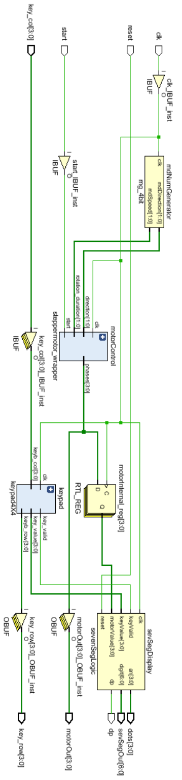

APPENDIX B
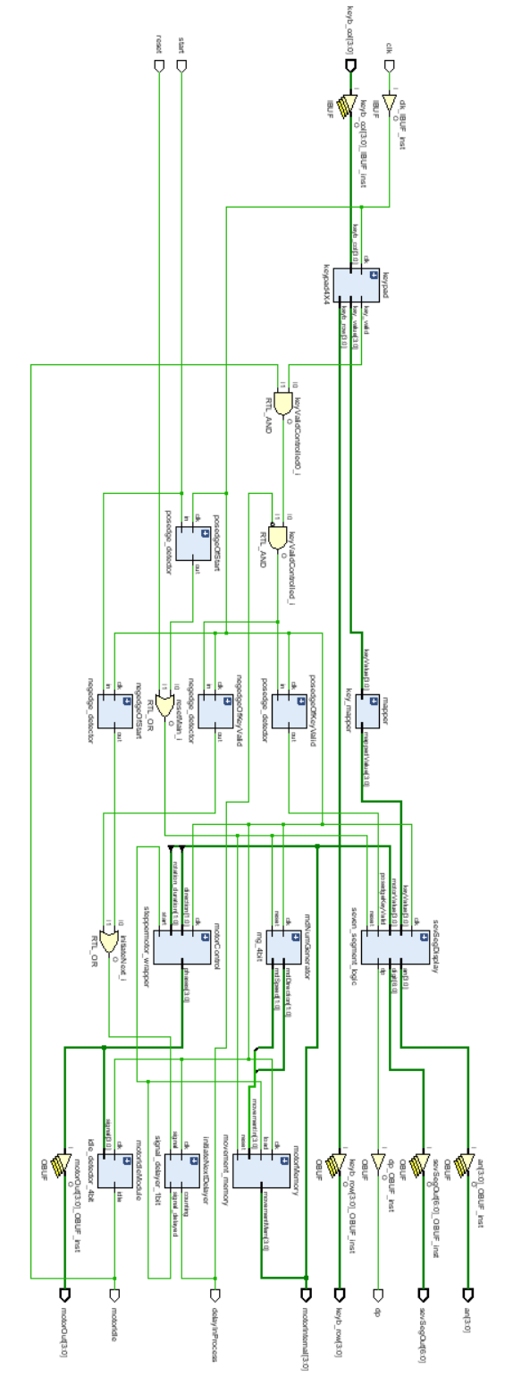

APPENDIX C
Real Values of Movements:
SL: 00
SR : 01
LL : 10
LR : 11

Mapped Values of Movements:
SL: 11
SR: 00
LL: 10
LR: 01

Mapping Table:

Key | 1st Mov | 2nd Mov
1 = SL SL
2 = SL LL
3 = SL LR
4 = LL SL
5 = LL LL
6 = LL LR
7 = LR SL
8 = LR LL
9 = LR LR
0 = SR LL
A = SL SR
B = LL SR
C = LR SR
D = SR SR
* = SR SL
# = SR LR

